How to separate GameServer
(When you are intend to increase your game server capacity)

First copy Master Server’s All Files to Slave Machine(new game server) and edit some files and delete some files and folders

1. Main Game Server

- Mir200 Folder
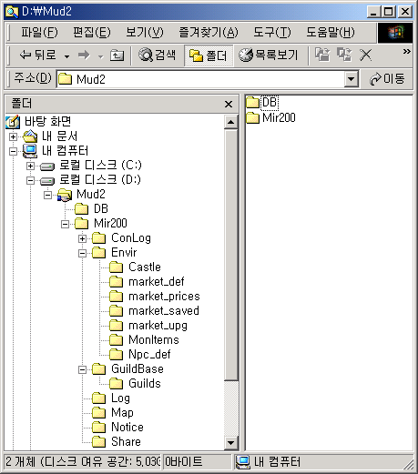
  - Envir : Game Environment File and Folder
  - GuildBase : Guild Information.
  - Log : Server Message and Error Message
  - Map : Map files
  - Notice : Notice file
  - Share : Sharing folder
  - !Msglist : Warning, Error and Information Message.
  - !servertable : Server and Gate’s Connection
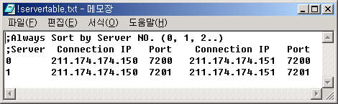
Run Gate Public IP
Gate Port

0 means Master Server, Other number means slave server. We can add many server machine in this way. 0, 1, 2… etc.

RunGate Machine can run many RunGate program.

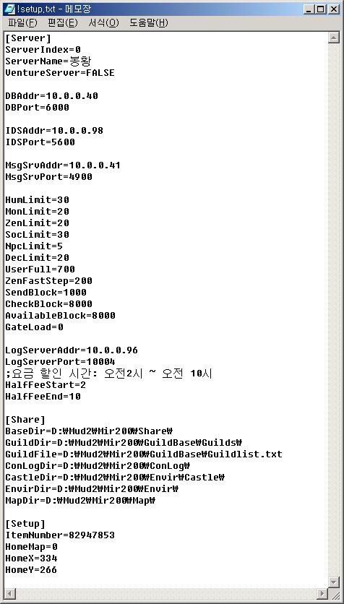
Set for Test server,(change false to true )
Game Sharing Folder
You should Change your machine folder
Item Serial Num. Auto increase
Message Server(Master Server)’s Private IP
Server Index : 0 means Master
GameDB
Login DB
Game Log Server
Discount Time if Fee server

- Envir Folder

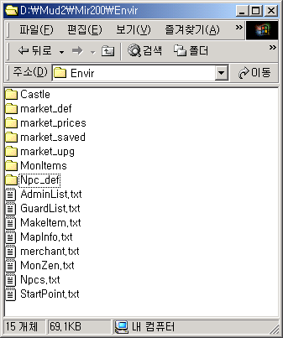

  - Castle : It contains Castle owner Guild and Castle Siege time(wall conquest war time) (It is essential new folder so you should make it- necessary)
  - market_def : Market NPC’s dialogue
  - market_prices : Market Price
  - market_saved : Marktet saved Item’s class and amount
  - market_upg : Weapon refining system’s Folder(It is essential new folder so you should make it- necessary)
  - Monitems : Item Drop rate
  - Npc_def : NPC’s dialogue

  - AdminList : It concerned with GM Character appointment @ReloadAdmin
If AdminList.txt file show as below table.

* : Means Real GM Character so All GM Command can be used
1 : Means Monitoring Character. It cannot use Some GM Command.

  - GuardList : Guard Position
  - MakeItem : Posion power material
  - MapInfo : Map Information
  - merchant : Marcket Position and deal item
  - MonZen : Mob Generation
  - Npcs : NPC’s Information
  - StartPoint : Starting Position

2. Slave Server

- Mir200 Folder
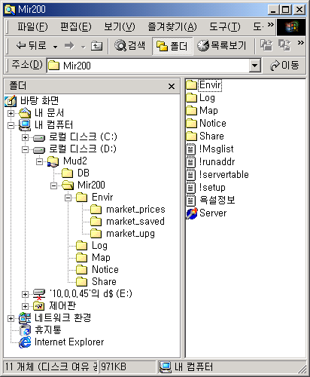

All files are the same as the master server. Except you should delete ConLog folder and edit !setup.txt file
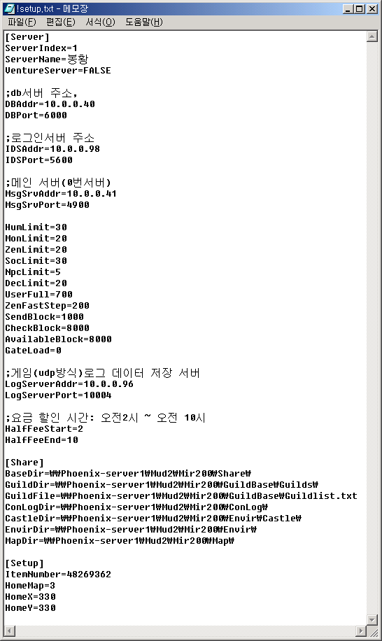
Edit Server Index 1
Edit it
- Setup for Mob, Item and martial art.
You must setup Boland Delphi BDE Administrator and Database Desktop and set HeroDB as under.
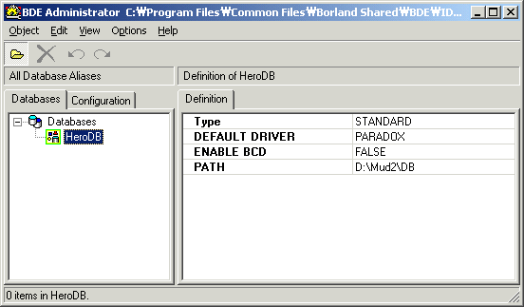

3. Login Server

  - !serveraddr : You should add All Game Server’s private IP.

Game DB Server

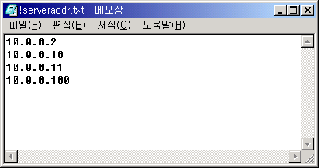
Login Gate
Game Server

